# How to use cmd prompt inside Eclipse..?

By: Waqas Ahmad (bitguider@gmail.com)

1. In the Eclipse tool go to Run -> External Tools -> External Tools Configurations

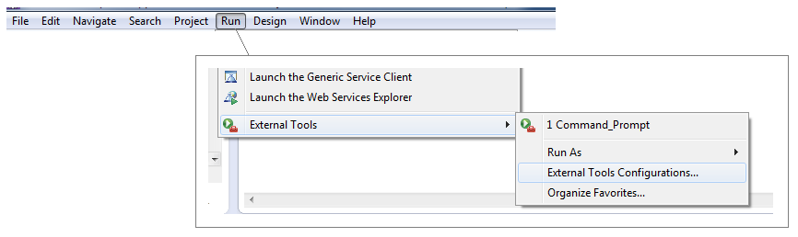

1. Select Program and click “New Launch Configuration”

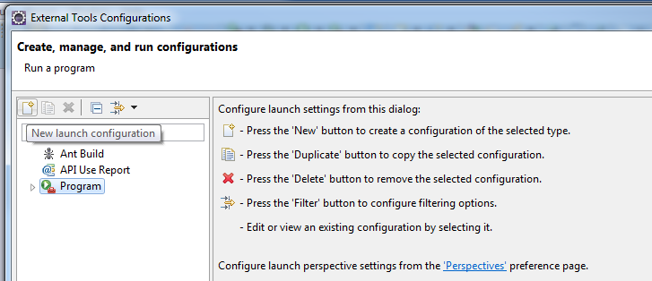

1. Set Location, Working Directory under in **main** tab
   1. Location : C:\Windows\System32\cmd.exe
   2. Working Directory : for example “C:\devl\NWBankUI\workspace\ws-client-build”

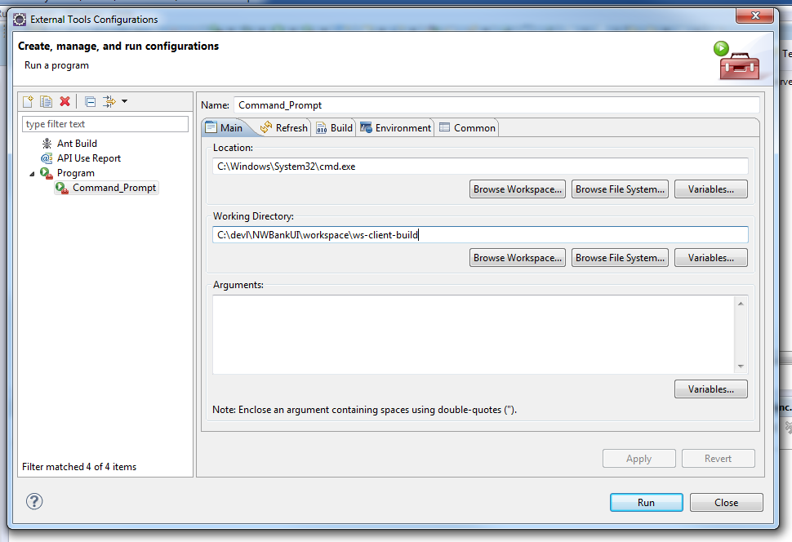

1. Make sure “Allocate console” is checked Under **Common** tab

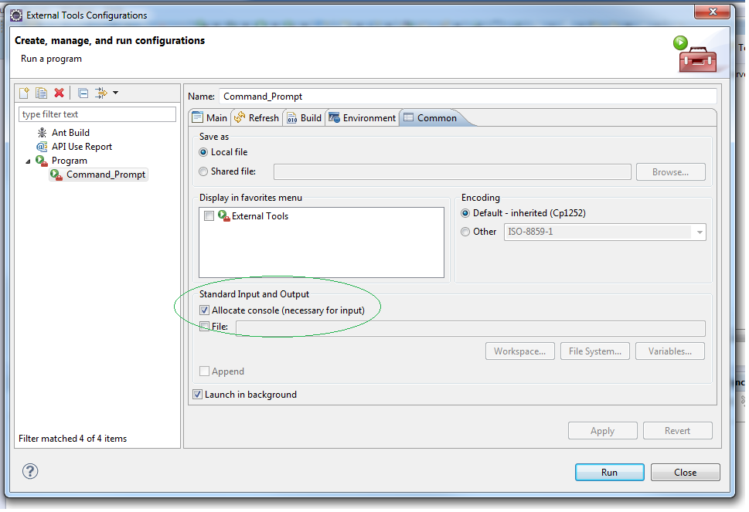

1. Hit Apply and Run.
2. In your eclipse console tab you should see your working directory, that’s it you are done ☺

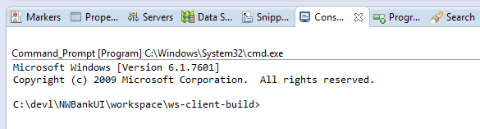

1. You can switch console screen to see server log or use it as cmd by selecting “Display selected console”

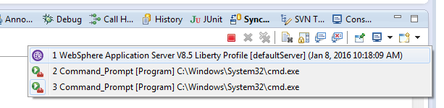

1. You can also set more than one console view, 1 for cmd another for server log

